LIBSPACE

Title-LibSpace
- LibSpace API
- Robust backend for library operation
- Team leader :
- Sanjana kumari M
- Team Members
    - Sanajana K
    - Reshma A
    - Nethera P
    - Booviga N

Overview
@ Web-based library management system
A web-based library management system is an online application that helps libraries manage their daily operations through a browser. Instead of using paper records or offline software, everything is handled on the internet.

✨ Key Points
- User Access: Students or members can register, log in, and manage their accounts online.
- Book Management: Librarians or users can add new books, view available books, update book details, or delete books.
- Authentication: Secure login ensures only authorized users can access or modify data.
- Database Integration: All information (users, books, transactions) is stored in a database like MongoDB or MySQL.
- Anywhere Access: Since it’s web-based, users can access the system from any device with internet.
- Efficiency: Automates manual tasks, reduces errors, and saves time.

* Secure authentication
Secure authentication means making sure that only the right, authorized users can access a system. It protects sensitive data and prevents unauthorized access.
Key Points:
- User Verification: The system checks if the username/email and password are correct.
- Password Protection: Passwords are stored in a safe way (hashed using tools like bcrypt) so they cannot be easily stolen.
- Token-Based Access: After login, the system gives a JWT (JSON Web Token). This token proves the user is valid and must be shown for every request.
- Middleware Security: Routes are protected with middleware that checks the token before allowing access.
- Logout & Blacklist: When a user logs out, their token is invalidated (blacklisted) so it cannot be reused.
* CRUD operations on books
CRUD stands for Create, Read, Update, Delete. These are the four basic functions used to manage data in a system. In LibSpace, CRUD is applied to books:
- Create (Add Book): A user can add a new book by entering details like title, author, and URL.
- Read (View Books): The system allows users to see the list of all books or fetch a specific book by its ID.
- Update (Edit Book): Users can change book details, such as updating the title or author information.
- Delete (Remove Book): A user can permanently remove a book from the library database.

Prerequisites
- Skills: JavaScript, Node.js, MongoDB/MySQL
- Tools: VS Code, Postman, Browser
- Setup: Node.js + npm, environment variables

Features
- User Authentication (Register, Login, Delete)
- Book Management (Add, View, Update, Delete)
- User–Book Relationship (One-to-Many)
- Security (JWT, bcrypt, middleware)

Database Design
- User Schema: name, email, password
- Book Schema: title, author, url, user reference
- One-to-Many relationship

Library Space Project – Phases Overview

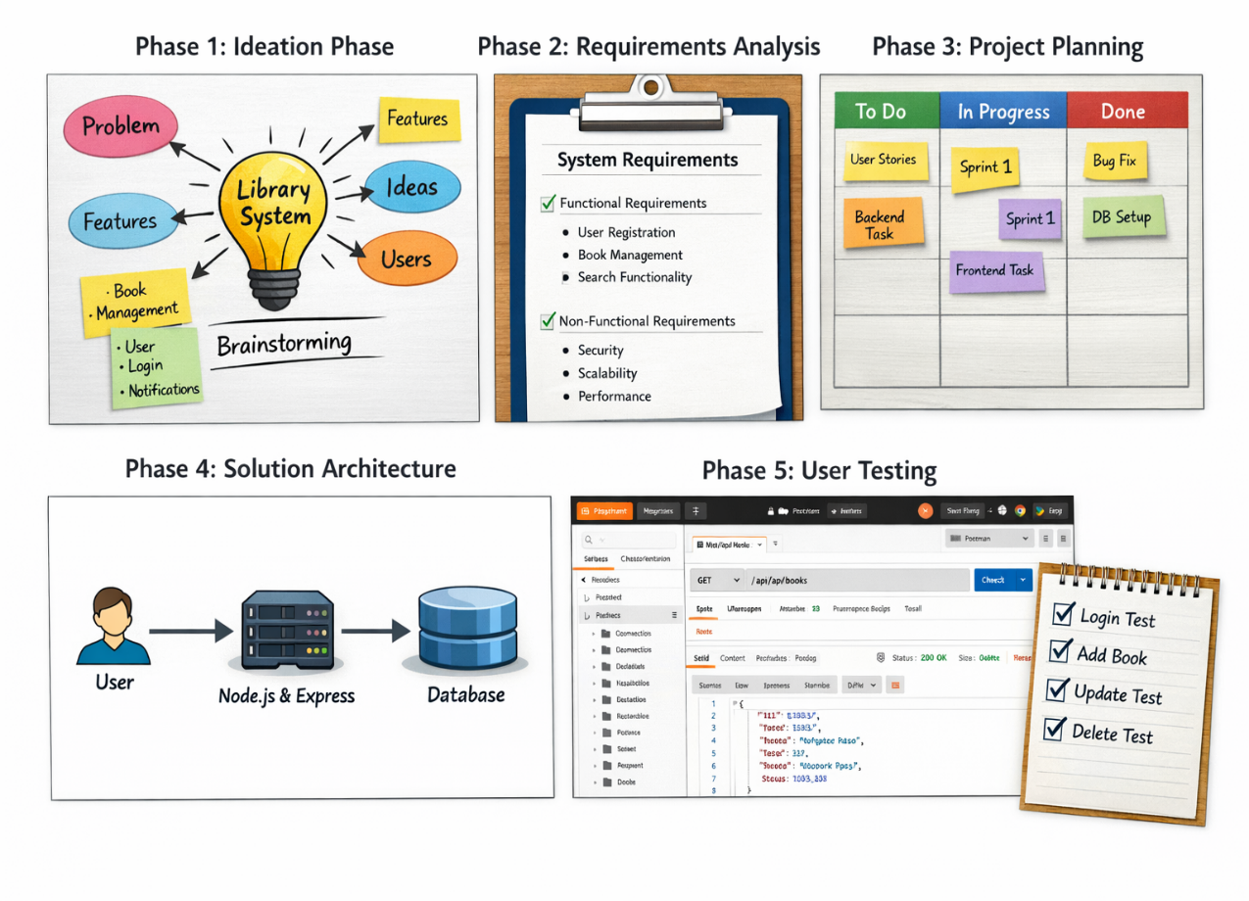

Phase 1 :
Ideation Phase

• Identify problems in managing books in small libraries.
• Brainstorm project ideas such as Library System, Blog API, or Task Manager.
• Select LibSpace Backend System as the final project idea.
• Focus on secure authentication and book management

Phase 2 :
Design Requirements

• Functional Requirements: User registration and login.
• Add, update, delete, and view books.
• Secure authentication using JWT.
• Non Functional Requirements: Security, scalability, performance, maintainability

Phase 3 :
Project Planning

• Create the product backlog.
• Define development tasks.
• Assign story points to tasks.
• Plan sprint schedule.
• Track development progress.

Phase 4 :
Solution Architecture

• Technologies used: Node.js, Express.js, MongoDB.
• Use JWT for authentication.
• Use bcrypt for password security.
• Follow REST API architecture.
• Use modular backend structure.
Phase 5 :
User Acceptance Testing

• Test user registration feature.
• Test user login functionality.
• Verify JWT authentication.
• Test CRUD operations for books

CONCULSION:
- The Library Space Backend System project was developed to manage library books and users efficiently.
- The system is built using Node.js, Express.js, and MongoDB for backend development.
- It provides features like user registration, login, and book management through REST APIs.
- Security is ensured using JWT authentication and bcrypt password encryption.
- The project was developed in a structured manner using five phases.
- Phase 1 focused on identifying the problem and selecting the project idea.
- Phase 2 defined the functional and non-functional requirements of the system.
- Phase 3 involved project planning, task management, and sprint scheduling.
- Phase 4 and Phase 5 focused on system architecture design and user acceptance testing.
- Overall, the project helps in understanding backend development, database integration, and secure API design.

